

**Software Design and Architecture**

**Sir Atif Jillani**

**Project Deliverable 3: SRS VERSION 2.0**

1. **Sequence Diagrams**
2. **Revised System Sequence Diagrams**
3. **Revised Use Case Diagram**
4. **Revised Extended Use-Cases**

**Daniyal Khan : 20i-1847**

**Ayesha Ahmed : 20i-2424**

**Mehreen Ishtiaq : 20i-0781**

**Flight Reservation**

**Flight Management**

**Flight Scheduling**

**Airport Management**

Contents

Flight Management 3

UC-01: Scheduling a Flight: 3

System Sequence Diagram: Scheduling a Flight 7

Display Routes: 8

Create Flight: 9

Calculate Final Fares: 10

UC-02: Removing a flight: 11

Removing a Flight: System Sequence Diagram 14

Sequence Diagrams: Removing a Flight 15

1. Display Flights: 15

2. Removing A Flight 16

UC-03: Track Current Flight’s Status: 16

System Sequence Diagram: Tracking Flight’s Status 19

Sequence Diagrams: 20

1. Track Flight Details: 20

Booking Management 21

System Sequence Diagram: Booking Management 21

Sequence Diagrams: Booking Management 25

UC-04: Book a flight: 25

UC-05: Cancel a booking: 28

UC-06: Check available flights (Fare, Capacity, Route (departure, destination, stops) 30

UC-07: View Booking: 33

Route Management 34

UC-08: Adding a route: 34

System Sequence Diagram: Adding a Route 37

Sequence Diagram: Add Route 38

Add Route 38

UC-09: Updating a route 38

System Sequence Diagram: Updating a route 41

Sequence Diagram: Updating a route 41

1. Display Routes: 41

2. Update Route(): 42

UC-10: Removing a route 43

System Sequence Diagram: Route Removing 45

Removing a route 45

Sequence Diagram: delete Route 46

Delete Route 46

Payment 46

UC-11.1: Payment with cash 48

UC-12: Payment with external Microfinance FRS (T.B.D) 49

Airplane Management 51

UC-14: Update Airplane’s Flight Status 52

UC-15: Manage Airplanes in FRS 54

Airport Management 56

UC-16: Add Airport 57

UC-17: Remove an Airport 59

Inquiry Management 62

UC-18: Redirecting an Inquiry: 63

UC-19: View/Update/Delete an Inquiry 64

UC-20: Add an Inquiry 65

# Flight Management

## UC-01: Scheduling a Flight:

| **Sr.**  **No** | **Section** | **Content / Explanation** |
| --- | --- | --- |
| 1 | **Designation** | UC-01 |
| 2 | **Name** | **Schedule a Flight** |
| 3 | **Authors** | Daniyal, Ayesha, Mehreen |
| 4 | **Priority** | Important for system’s success: High  Technological Risk: High |
| 5 | **Scope** | This use case deals with how the Flight manager schedules a flight. |
| 6 | **Criticality** | High |
| 7 | **Stakeholders and interests** | * Flight Manager: Responsible for the entire scheduling of a flight. He wants correct retrieval of data to avoid any hazard. * Pilot: Responsible for piloting the flight. I Want to get all the necessary info about the flight to correctly pilot it. * Flight crew: Responsible for managing Passengers. * Technical crew: Responsible for maintaining the airplane of the flight. * Navigation system: Responsible for identifying the route of the Airplane. * Company: Wants to give their Passengers a tension free and satisfactory ride, and wants to record all the data for future use. * Passenger: Wants to travel faster and with minimum headaches. |
| 8 | **Description** | From the FRS main Screen panel, the Flight manager opens the Flight scheduling panel. The FRS displays a list of routes and date of flight. The Flight manager selects a route and date. The FRS then displays the list of available airplanes that meets the route and date criteria. The flight manager then confirms the Flight by entering the increase or decrease in the ticket price. |
| 9 | **Trigger Event** | The flight manager wishes to schedule a Flight. |
| 10 | **Actors** | Flight Manager, FRS |
| 11 | **Pre-Conditions** | 1. The airplane must be available for scheduling. 2. There must be route available for the city of departure and arrival. 3. The Flight Manager must be logged in. |
| 12 | **Post-Conditions** | 1. Flight is scheduled. 2. Flight records are updated. 3. The fare is generated. 4. Flight is available for booking 5. Airplane Records are updated |
| 13 | **Result** | Flight scheduled |
| 14 | **Main Scenario** | |  |  | | --- | --- | | Flight Manager | Flight Scheduling system | | 1. The Flight Manager opens the Flight scheduling Panel.      1. The flight manager enters the desired departure, arrival and Date and time of the flight.     3. The flight manager may increase or decrease the price. | 1a. The FRS displays the Flight Scheduling options.  1b. The FRS asks the flight manager for city of departure and arrival, Date and time of the flight.  2a. The FRS then displays the Ticket prices (economy, business) and asks for an increase or decrease in price.  3a. The FRS schedules the flight for available airplane.  4b. The FRS displays the details (Fare, capacity, Route, Flight ID) of the Flight. | |
| 15 | **Alternative Scenario** | 1. In case of FRS failure before Flight manager saves the data:    * 1. Flight manager logs in again      2. The FRS will not have any information saved. The Flight manager will have to enter the details again. 2. In case of unavailability of Airplanes:    1. 1. The Flight manager will have to enter alternative timings for flight departure.   If there is no route between the departure city and arrival city, the Flight manager will have to add a route first before scheduling. Else, the FRS will automatically add a route. |
| 16 | **Exception Scenario** | 1. The FRS is unable to log in. 2. The FRS is unable to Airplane Data. 3. The FRS is unable to Route Details. 4. The FRS is unable to fetch airport details. |

## System Sequence Diagram: Scheduling a Flight

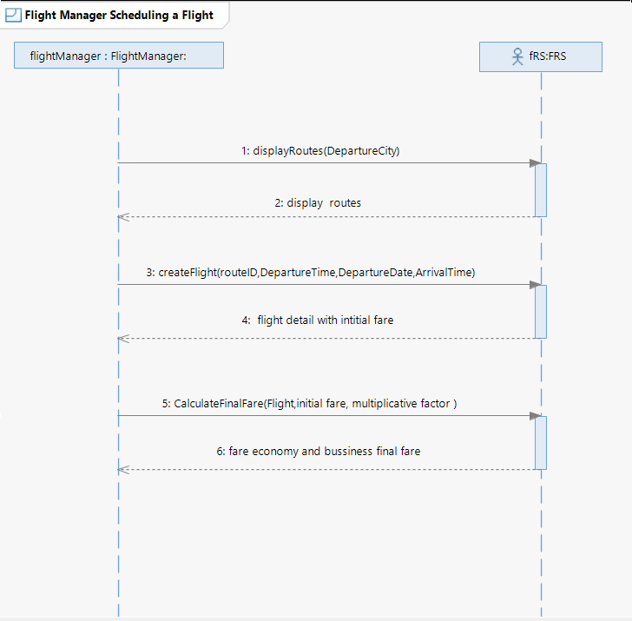

### Display Routes:

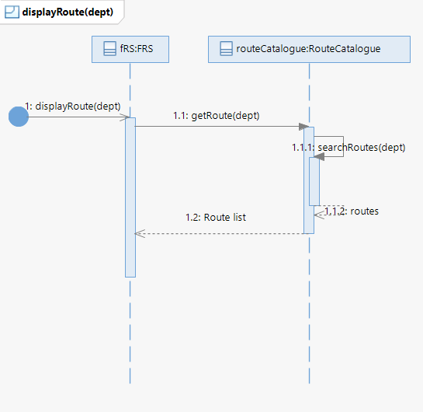

### Create Flight:

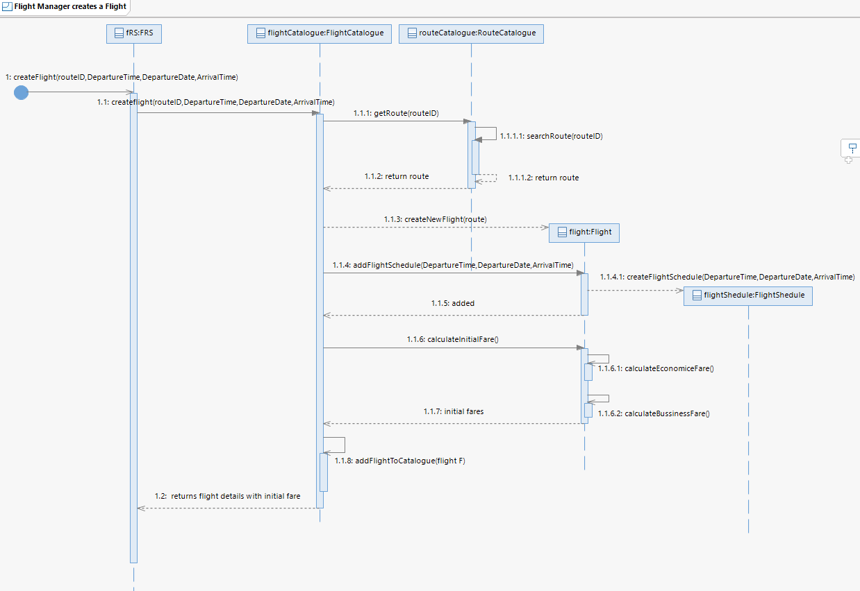

### Calculate Final Fares:

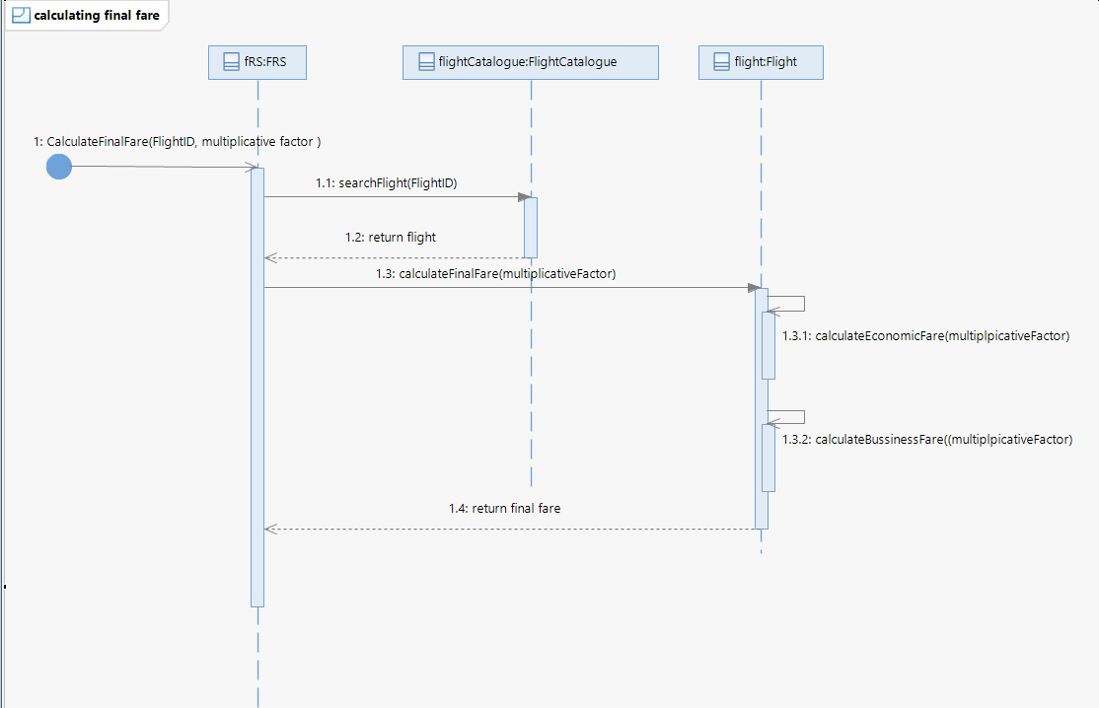

## UC-02: Removing a flight:

|  |  |  |
| --- | --- | --- |
| Sr. | **Section** | Content / Explanation |
| 1 | **Designation** | UC-02 |
| 2 | **Name** | **Remove a Flight** |
| 3 | **Authors** | Daniyal, Ayesha, Mehreen |
| 4 | **Priority** | Important for system’s success: **High** Technological Risk: **High** |
| 5 | **Scope** | This use case deals with how the Flight Manager removes a flight from the schedule. |
| 6 | **Criticality** | High |
| 7 | **Description** | The Flight Manager removes a flight from the schedule by entering its flight ID in the Flight removing Panel of the FRS. |
| 8 | **Trigger Event** | The Flight Manager wants to remove a flight from the schedule. |
| 9 | **Actors** | Flight Manager, FRS |
| 10 | **Pre-Conditions** | 1.        Flight has been scheduled.  2.         Flight Manager is logged in. |
| 11 | **Post-Conditions** | 1.        Flight is removed from the schedule. 2.        Airplane is free to be scheduled for another flight. 3.        Flight records are updated 4. Airplane Records are updated |
| 12 | **Result** | Flight is removed from the schedule. |
| 13 | **Main Scenario** | |  |  | | --- | --- | | Flight Manager Action | System Responsibility | | The Flight Manager opens the Flight management Panel and Selects ‘Flight Removing’. |  | |  | The FRS displays management panel. | |  | FRS displays the Flight Removing Panel. | | The Flight manager enters the flight ID of the flight he wants to remove in the Flight removing Panel of the FRS |  | |  | The FRS displays the details (arrival place, date, time and estimated fare) of the scheduled flight. | | The Flight manager clicks on the Remove Flight link. |  | |  | The FRS prompts “Do you want to remove the flight?” | | The Flight Manager clicks on the Remove button. |  | |  | The FRS displays a message that flight (with flight number) has been removed from the schedule. | |
| 14 | **Alternative Scenario** | In case of system failure:  To support recovery and correct scheduling, the system shall have saved the sensitive information.  1. Flight manager logs in again  2. The system resumes from the prior state. |
| 15 | **Exception Scenario** | 1. The FRS is unable to log in. 2. The FRS is unable to Airplane Data. 3. The FRS is unable to Route Details. 4. The FRS is unable to fetch airport details. 5. The FRS is unable to save the updates i.e., the flight removal 6. Flight ID is invalid. |

## Removing a Flight: System Sequence Diagram

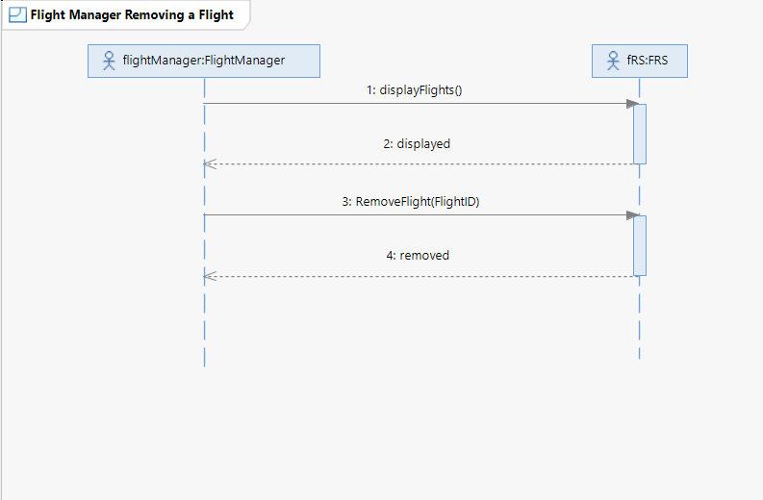

## Sequence Diagrams: Removing a Flight

### 1. Display Flights:

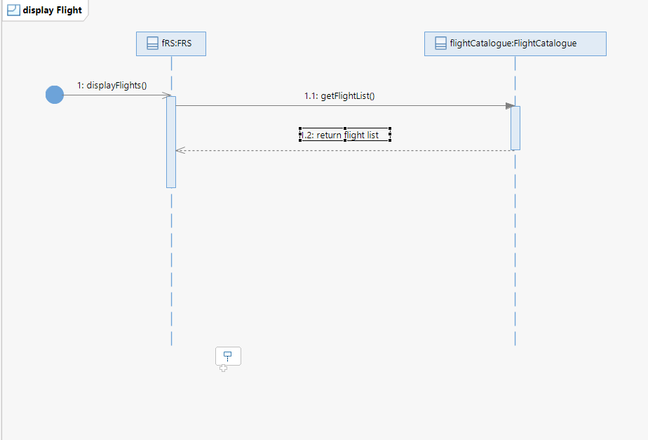

### 2. Removing A Flight

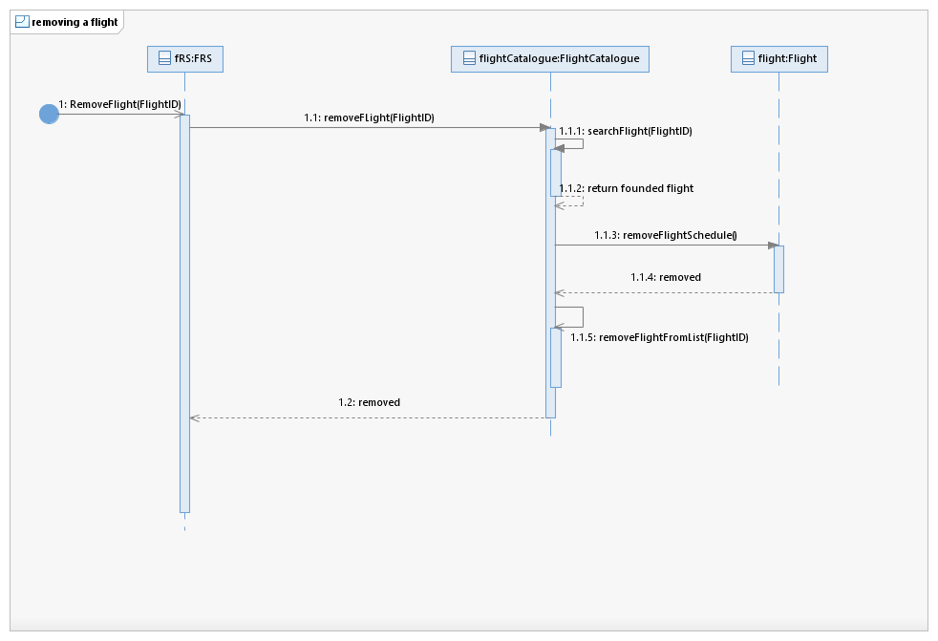

## UC-03: Track Current Flight’s Status:

|  |  |  |
| --- | --- | --- |
| Sr.  No | **Section** | Content / Explanation |
| 1 | **Designation** | UC-03 |
| 2 | **Name** | **Track Flight Status** |
| 3 | **Authors** | Daniyal, Ayesha, Mehreen |
| 4 | **Priority** | Important for system’s success: **High**  Technological Risk: **High** |
| 5 | **Scope** | This use case deals with how the Flight Manager tracks the Status of a flight. |
| 6 | **Criticality** | High |
| 7 | **Description** | The Flight Manager tracks the status of a flight by entering |
| 8 | **Trigger Event** | The Flight Manager wants to track the status of a flight. |
| 9 | **Actors** | Flight Manager |
| 10 | **Pre-Conditions** | Flight has been scheduled.  Flight Manager is logged in. |
| 11 | **Post-Conditions** | Flight Manager can see the status (the current location of airplane), route of the flight |
| 12 | **Result** | Flight Status is displayed. |
| 13 | **Main Scenario** | |  |  | | --- | --- | | Flight Manager Action | System Responsibility | | The Flight manager opens up the manage flights page. |  | |  | The FRS prompts the flight manager to add the flight ID and departure place of the flight he wants to track. | | The Flight manager enters the flight number and the departure place of the flight that he wants to track. |  | |  | The FRS displays the details of the flight such as current location, route, and the time remaining to land the flight. | |  |  | |  |  | |
| 15 | **Exception Scenario** | The FRS is unable to fetch data from the GPS Satellite System.  The FRS is unable to save the updates as the airplane changes its location. |

## System Sequence Diagram: Tracking Flight’s Status

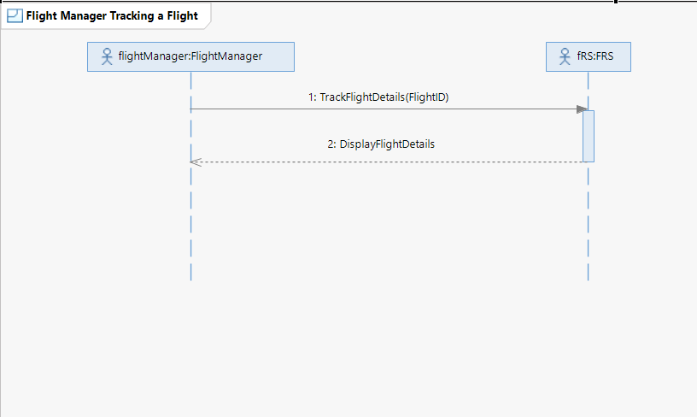

## Sequence Diagrams:

### 1. Track Flight Details:

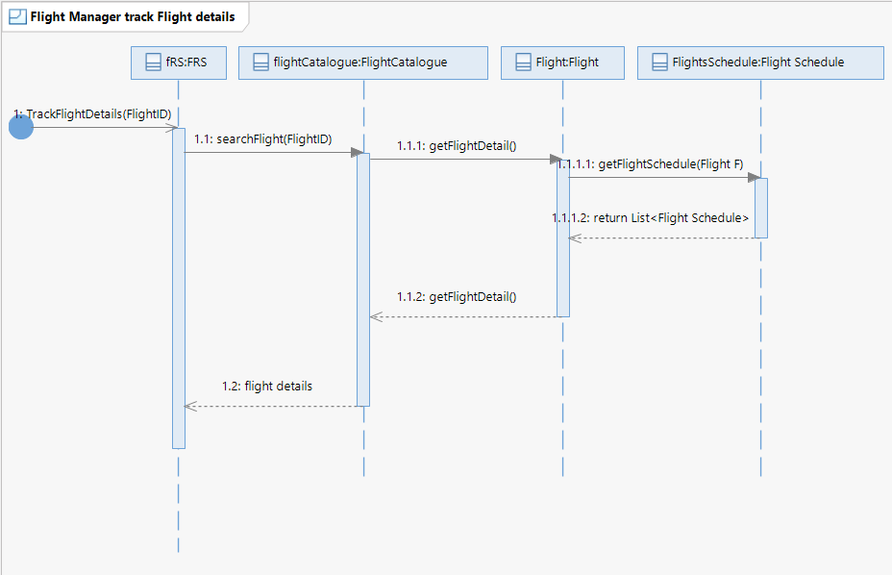

# Booking Management

## System Sequence Diagram: Booking Management

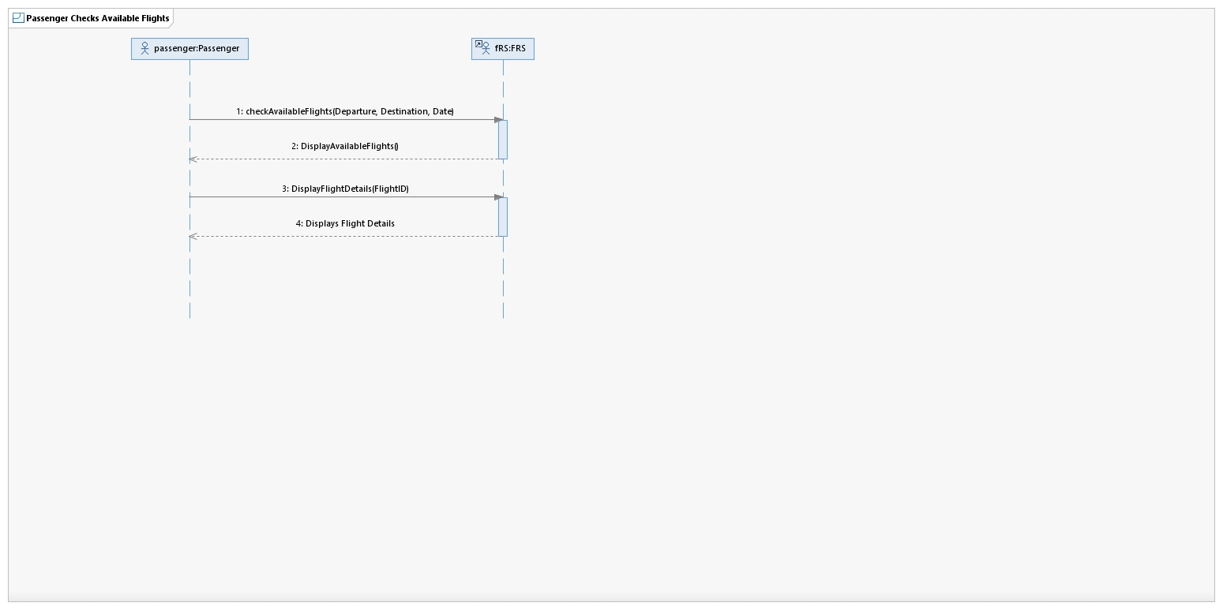

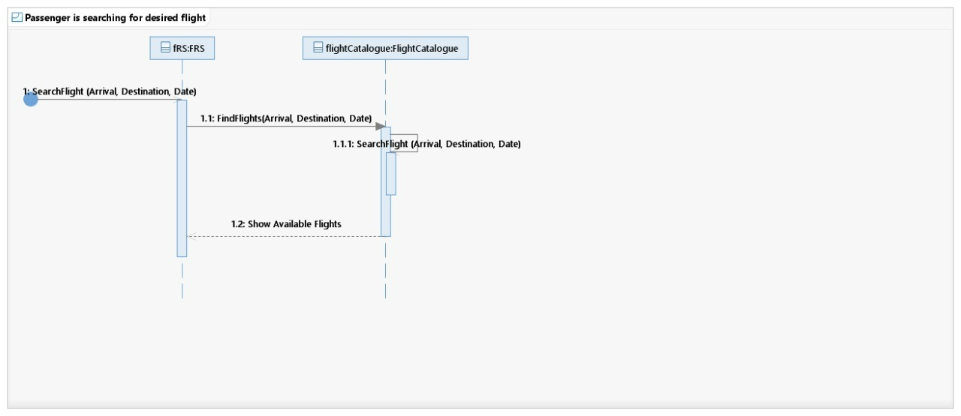

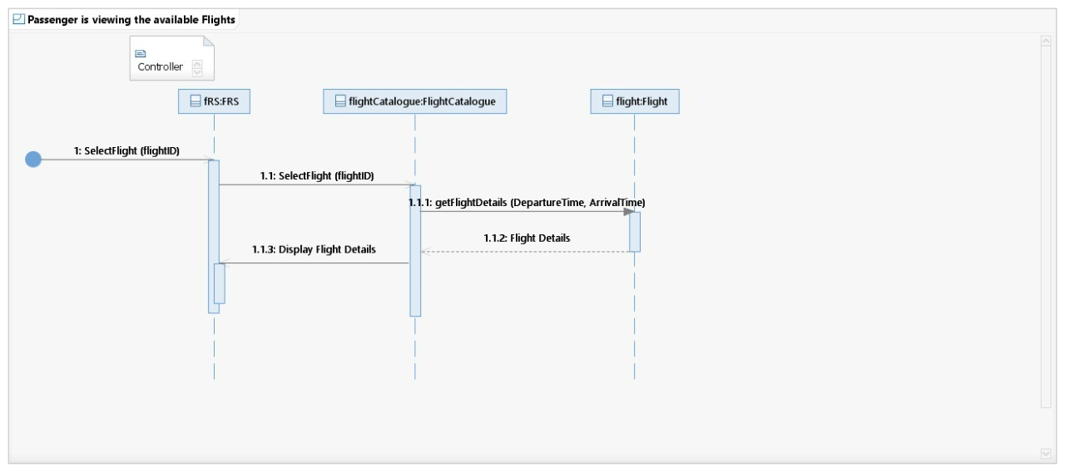

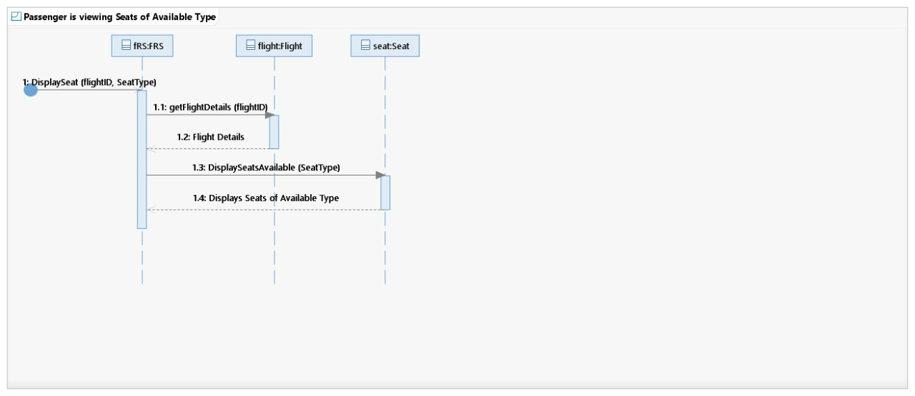

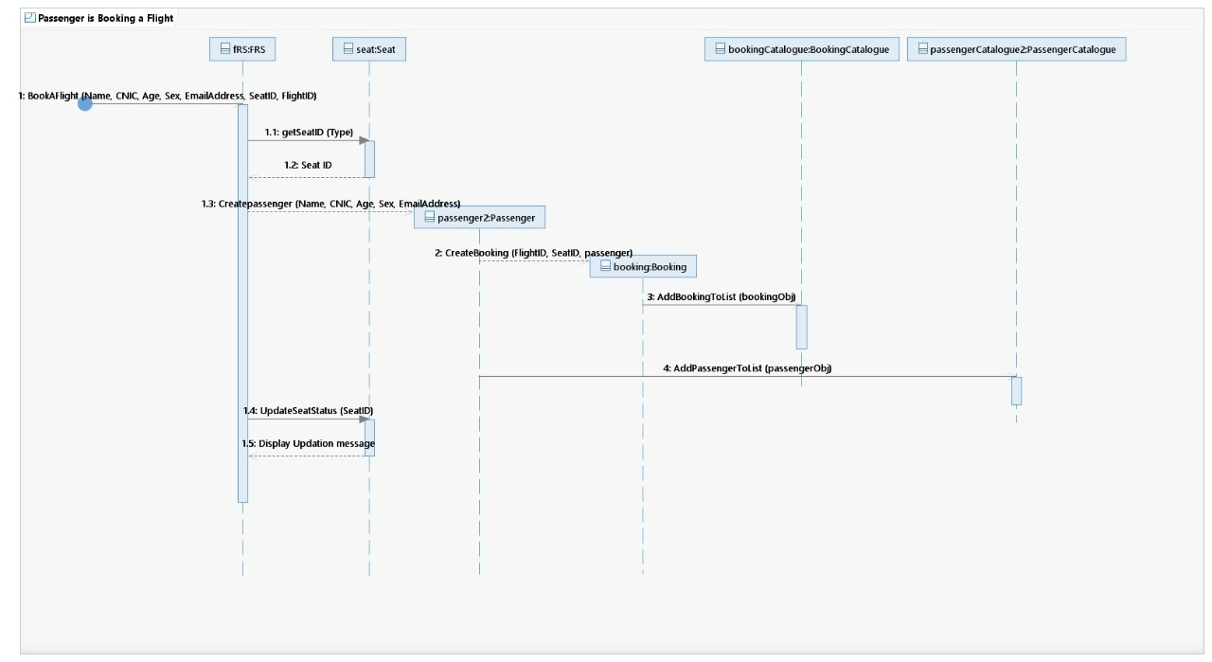 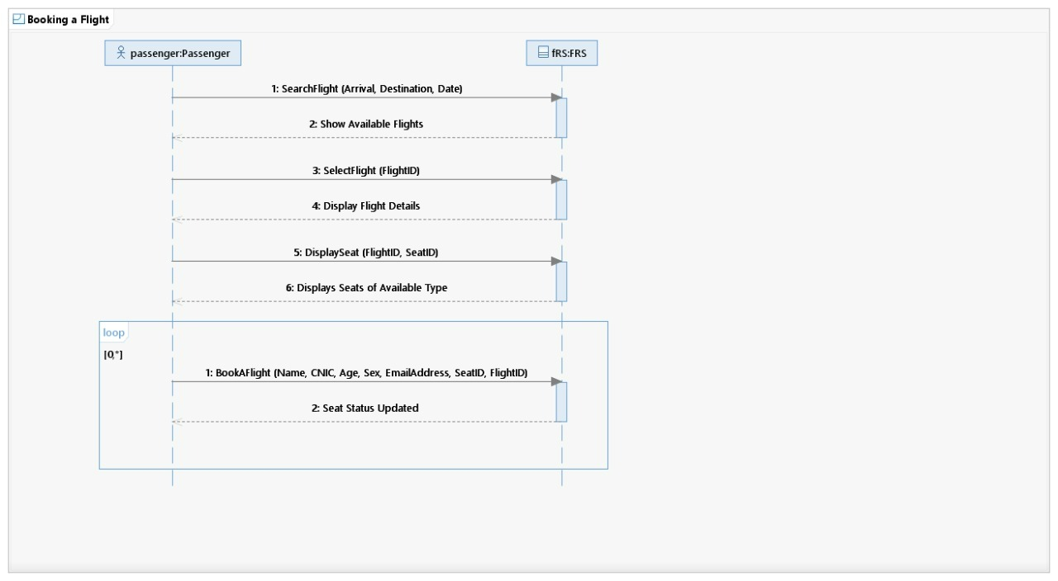

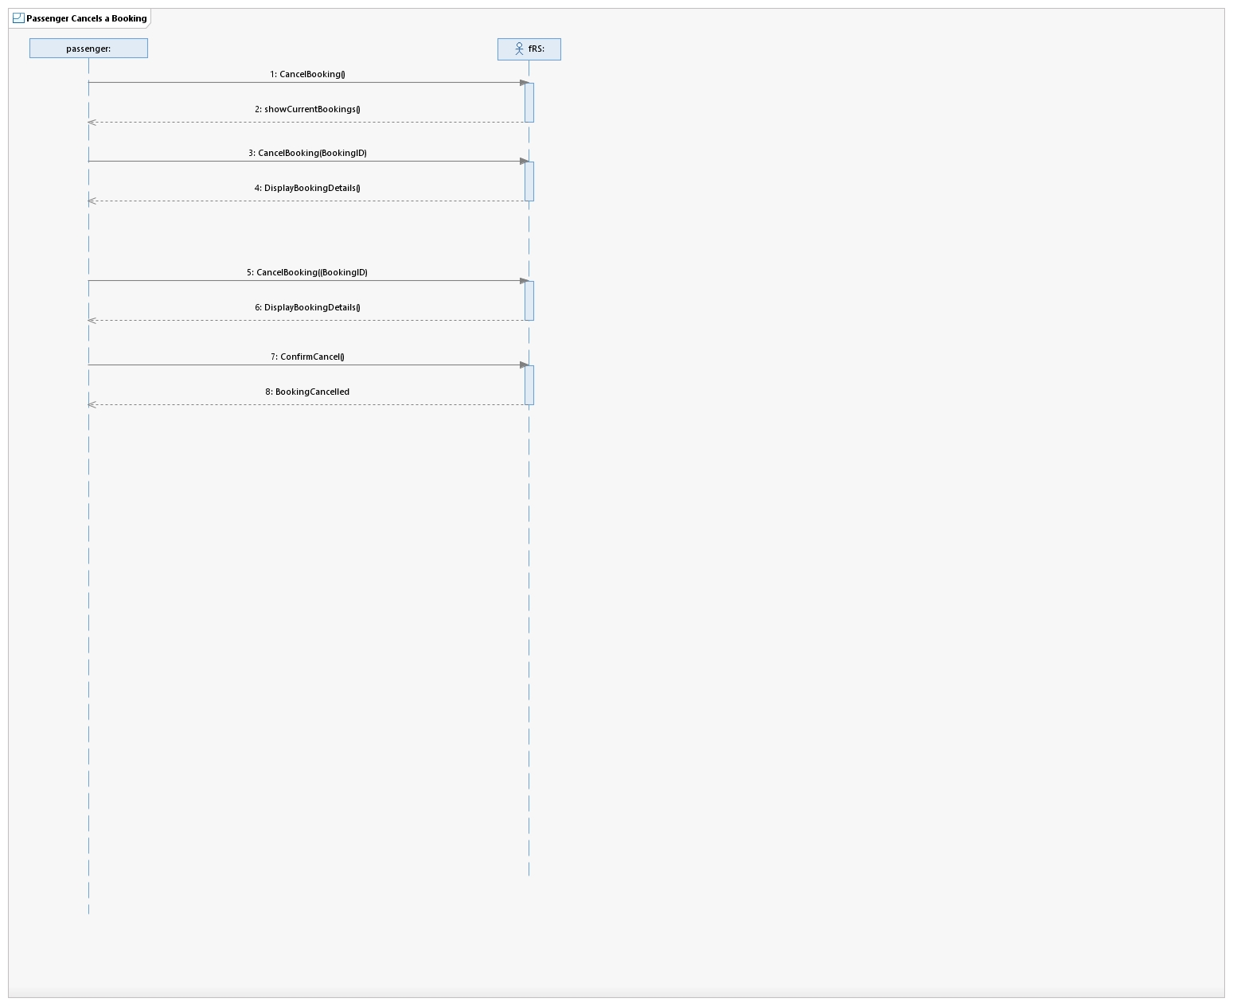

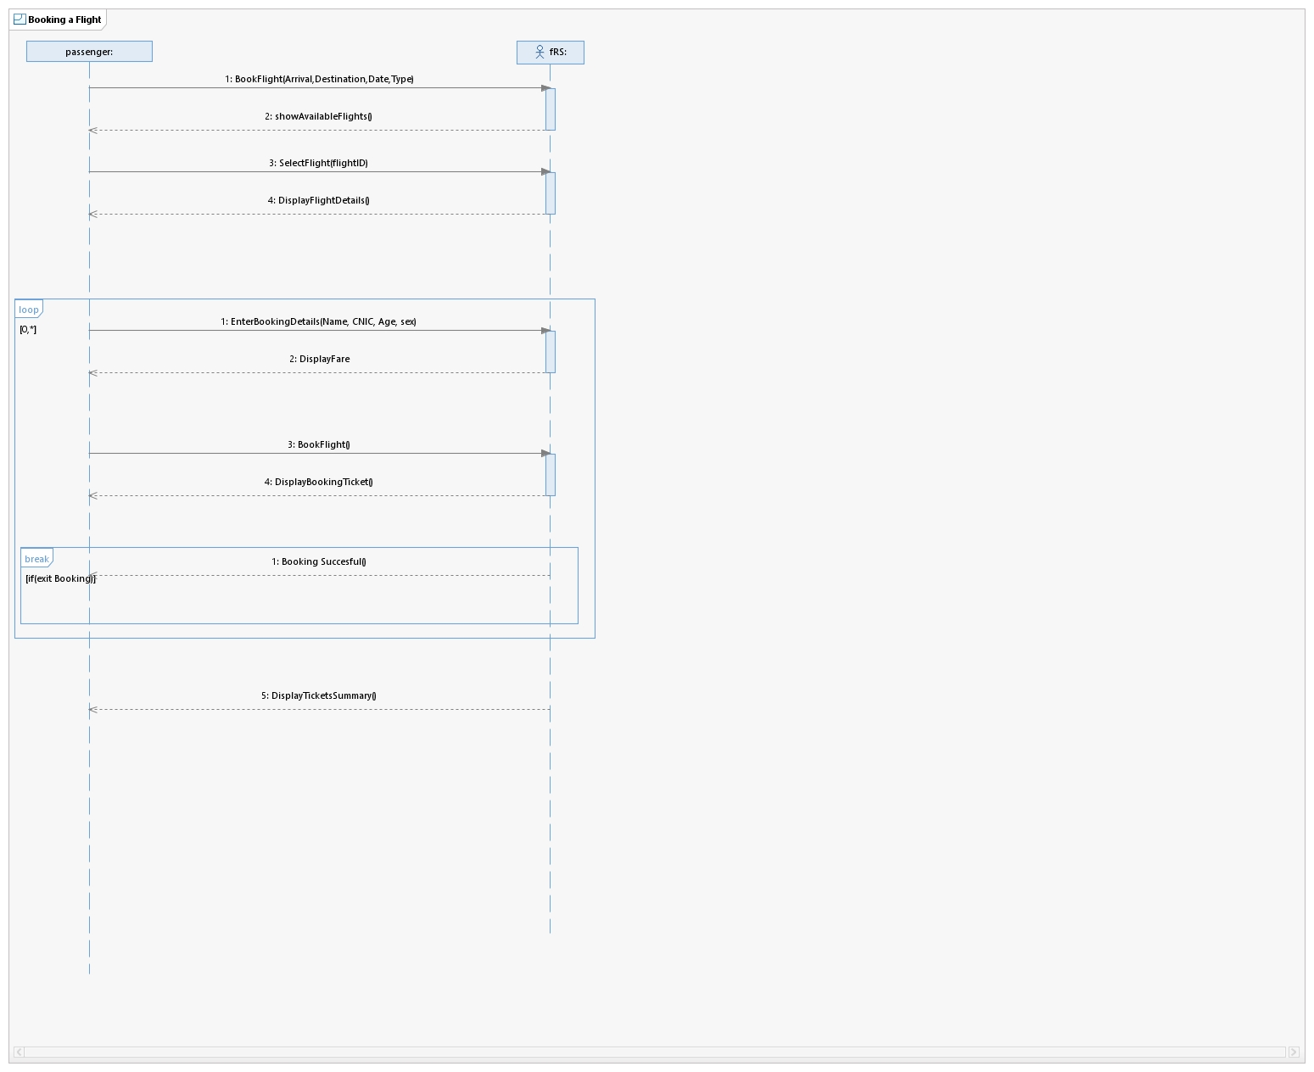

## Sequence Diagrams: Booking Management

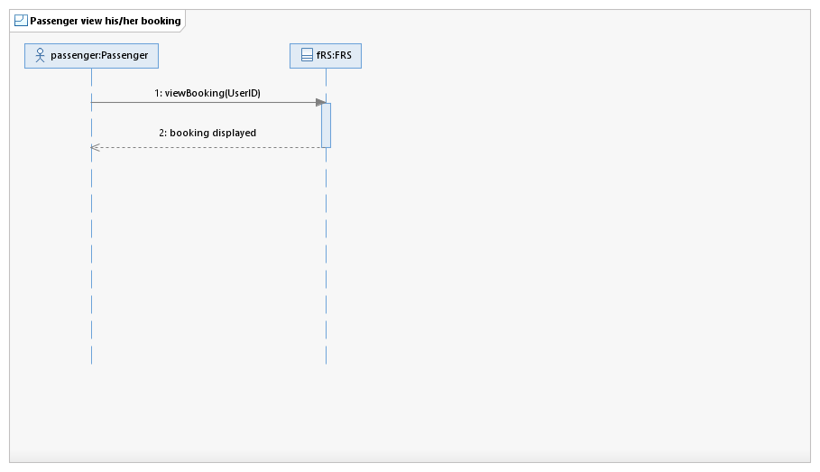

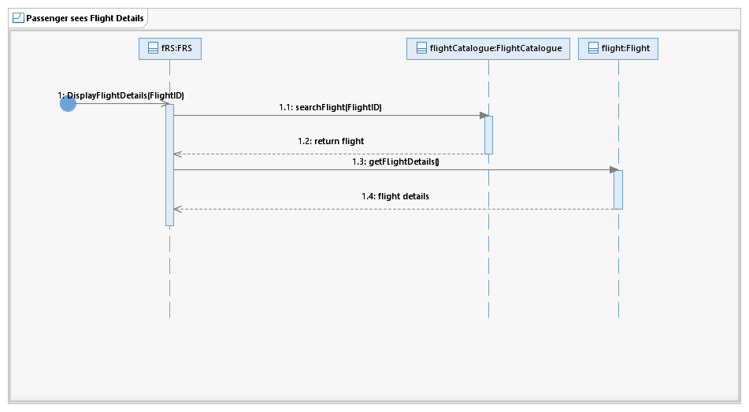

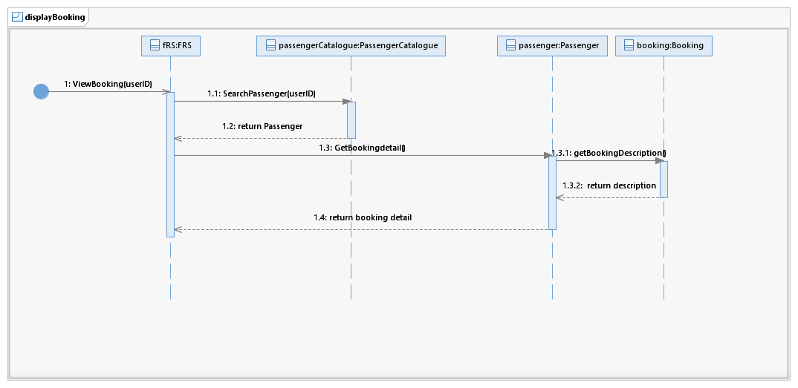

## UC-04: Book a flight:

|  |  |  |
| --- | --- | --- |
| Sr. No | **Section** | Content / Explanation |
| 1 | **Designation** | UC-04 |
| 2 | **Name** | **Book a Flight** |
| 3 | **Authors** | Daniyal, Ayesha, Mehreen |
| 4 | **Priority** | Important for system’s success: **High**  Technological Risk: **High** |
| 5 | **Scope** | This use case deals with how a Passenger books a flight. |
| 6 | **Criticality** | High |
| 7 | **Description** | In the Booking panel of the FRS, passenger enters a departure city, arrival city and the date of departure. The FRS displays a list of available flights, and the passenger books one of them. |
| 8 | **Trigger Event** | The Passenger wants to book a flight. |
| 9 | **Actors** | Passenger |
| 10 | **Pre-Conditions** | * Passenger has logged in to the FRS. * Flights have been scheduled by the Flight Manager. |
| 11 | **Post-Conditions** | * Seat is reserved. * The Booking Ticket is displayed. |
| 12 | **Result** | Seat(s) reserved. |
| 13 | **Main Scenario** | |  |  | | --- | --- | | Passenger Action | FRS Responsibility | | The Passenger opens up the booking page. |  | |  | The FRS shows Booking page to select departure city, arrival city, and departure date/time. | | The Passenger enters departure city, arrival city, and departure date/time. |  | |  | The FRS shows the details of available Flights. | | The passenger selects one of the Flight for Booking. |  | |  | The FRS displays all the necessary details of selected Flight (Fare, capacity, Remaining Seats) | |  | The FRS asks the Passenger to add the personal details (Name, CNIC, Age, Sex email/phone number) of each guest for whom he wants to book a flight. | | The Passenger enters the Booking details for reservation (Name, CNIC, Age, Sex, email). |  | |  | The FRS displays all the booking details including the confirmation number and Fare. | |
| 14 | **Alternative Scenario** | 1. In case of unavailability of flights  1. The FRS displays the message “No flight matches your selection”  2. The Passenger goes back to the booking page and  makes changes in any of his inputs. |
| 15 | **Exception Scenario** | 1. 1.. The Passenger is unable to sign in. 2. 2.. The FRS is unable to fetch flight Data. |

## UC-05: Cancel a booking:

|  |  |  |
| --- | --- | --- |
| Sr.  No | **Section** | Content / Explanation |
| 1 | **Designation** | UC-05 |
| 2 | **Name** | **Cancel a booking** |
| 3 | **Authors** | Daniyal, Ayesha, Mehreen |
| 4 | **Priority** | Important for system’s success: **High**  Technological Risk: **High** |
| 5 | **Scope** | This use case deals with how a Passenger cancels a booking of the flight. |
| 6 | **Criticality** | High |
| 7 | **Description** | The passenger cancels from his account by selecting a booking from the Cancel Booking Panel of FRS. |
| 8 | **Trigger Event** | The Passenger wants to cancel a booking. |
| 9 | **Actors** | Passenger |
| 10 | **Pre-Conditions** | Passenger has booked a flight.  Passenger is logged in. |
| 11 | **Post-Conditions** | * Booking is canceled. |
| 12 | **Result** | Booking of the desired flight has been canceled. |
| 13 | **Main Scenario** | |  |  | | --- | --- | | Passenger Actions | FRS Responsibility | | The Passenger opens up the Manage Booking page and clicks on Cancel Reservation. |  | |  | The FRS displays the bookings of that passenger and asks for a Booking ID to be cancelled. | | The Passenger enters the Booking ID of the Booking he wants to cancel. |  | |  | The FRS displays necessary booking details of selected booking(s) and shows a dialog box asking “Cancel the reservation?” | | The Passenger clicks on the Cancel button. |  | |  | The FRS displays a successful cancellation message upon cancellation. | |
| 14 | **Alternative Scenario** |  |
| 15 | **Exception Scenario** | The System is unable to find a booked flight. |

## UC-06: Check available flights (Fare, Capacity, Route (departure, destination, stops)

|  |  |  |
| --- | --- | --- |
| Sr. No | **Section** | Content / Explanation |
| 1 | **Designation** | UC-06 |
| 2 | **Name** | **Check available Flights** |
| 3 | **Authors** | Mehreen |
| 4 | **Priority** | Important for system’s success: **High**  Technological Risk: **High** |
| 5 | **Scope** | This use case deals with how a passenger checks available Flight. |
| 6 | **Criticality** | High |
| 7 | **Description** | The passenger enters departure and arrival city and selects any flight to see its status, date, time, fare, capacity, and route. |
| 8 | **Trigger Event** | The Passenger wants to check the status of an available flight. |
| 9 | **Actors** | Passenger |
| 10 | **Pre-Conditions** | ·        Passenger has logged in to the FRS. |
| 11 | **Post-Conditions** | ·        The passenger can see the status of the flight and other relevant booking details on the screen. |
| 12 | **Result** | The Flight status is displayed on the screen. |
| 13 | **Main Scenario** | 1.     The passenger clicks the flight status option from the homepage.  2.     The FRS asks the passenger to add departure city and arrival city.  3.     The passenger enters the departure city and arrival city.  4.     The FRS shows all the flights of next 2 to 3 days from the selected departure city to the selected arrival city with flight status (On Time, Canceled, or Delayed etc.), date and time.  5.     The passenger clicks on any of the flights to see more details related to booking.  6.     On clicking a flight number, the FRS shows the fare, capacity and route of the flight. |
| 14 | **Alternative Scenario** | 1. If the flight is not displayed by entering departure place and arrival, pass |
| 15 | **Exception Scenario** | ·        The system is unable to update the capacity of the airplane/ the number of seats reserved.  ·        The system is unable to fetch route details from Google Maps. |

## UC-07: View Booking:

|  |  |  |
| --- | --- | --- |
| Sr.No | **Section** | Content / Explanation |
| 1 | **Designation** | UC-07 |
| 2 | **Name** | **View Booking** |
| 3 | **Authors** | Daniyal, Ayesha, Mehreen |
| 4 | **Priority** | Important for system’s success: **High**  Technological Risk: **High** |
| 5 | **Scope** | This use case deals with how a passenger checks the booking status of his flight. |
| 6 | **Criticality** | High |
| 7 | **Description** | The passenger checks the status of his/her booking via FRS. |
| 8 | **Trigger Event** | The Passenger wants to check the booking status of a flight. |
| 9 | **Actors** | Passenger |
| 10 | **Pre-Conditions** | Passenger has logged in to the FRS |
| 11 | **Post-Conditions** | Passenger has successfully viewed his/her ticket. |
| 12 | **Result** | The Booking status of a flight is displayed on the screen. |
| 13 | **Main Scenario** | 1. The Passenger logs into the FRS. 2. The FRS displays the UI. 3. Through the UI, the passenger navigates to “View current bookings”. 4. The FRS responds by fetching the passenger’s Booking data from its database and displays the Passenger’s ticket(s) on the terminal that is displayed. |
| 14 | **Alternative Scenario** | 1. If the passenger is unable to log in, then    1. The admin can also check the flight status of any person through the FRS using the steps in the Main scenario if he is logged in to the FRS.    2. The Accounts Manager can also do 1a. |
| 15 | **Exception Scenario** |  |

# Route Management

## UC-08: Adding a route:

|  |  |
| --- | --- |
| **Section** | **Content / Explanation** |
| **Designation** | UC-08 |
| **Name** | Adding a route |
| **Priority** | Important for system’s success: **High**  Technical Risk: **High** |
| **Scope** | This use case deals with how the Flight Manager adds a route in the FRS . |
| **Criticality** | High |
| **Level** | User-goal |
| **Description** | The Flight Manager selects flight type, enters destination, stops, departure and makes a route. Route is added in the database. |
| **Trigger event** | The Flight Manager wishes to add a new route. |
| **Primary actor** | Flight Manager |
| **Stakeholders and interests** | Passenger: He wants to look at the routes of flight.  Flight Manager: he wants to keep check of every route.  He wants to manage the route. |
| **Pre-Conditions** | The Amin must be logged in.  The Flight Manager must be in the route management portal. |
| **Post-Conditions** | Route is added.  Route records are updated. |
| **Result** | Route added |
| **Main Scenario** | 1. The Flight Manager selects a route option. 2. The FRS displays an add route screen and gives options for direct or indirect flight. 3. Flight Manager selects direct flight. 4. FRS then asks the Passenger for departure and destination city. 5. The Flight Manager enters departure and destination. 6. FRS gives Flight Manager the option to   6.1  Confirm the route.  6.2  Cancel the route.  6.3  Change the route.   1. The Flight Manager confirms the route. 2. The FRS checks the database if the route is already present in the database and stores the route if it is not found in the database. |
| **Alternative Scenario** | 3a. The Flight Manager selects indirect flight.       3a.1 The FRS asks the Flight Manager number of stops he wants to enter.        3a.2 The Flight Manager enter the number of the stops he want to add.        3a.3 The FRS asks the Flight Manager to enter the name of stop (city).  5a. The Flight Manager enters departure, stops and destination.  6a. The Flight Manager select cancel the route option.        6a.1 The FRS brings the Flight Manager back to the route management portal.  6b. The Flight Manager selects a change route option.         6b.1 Go to step 4.  8a. The route is already present.         8a.1 The FRS will display message that route is already stored and give Flight Manager the option:  1. Add another route  2. Cancel the route.         8a.2 the Flight Manager select add another route.         8a.3 got to step 4.  8a.2.1 The Flight Manager cancels the route.         8a.2.1.1 The FRS takes Flight Manager to route management portal. |
| **Exception Scenario** | The FRS  server is down.  (2)  Refresh and add the route again. |

## System Sequence Diagram: Adding a Route

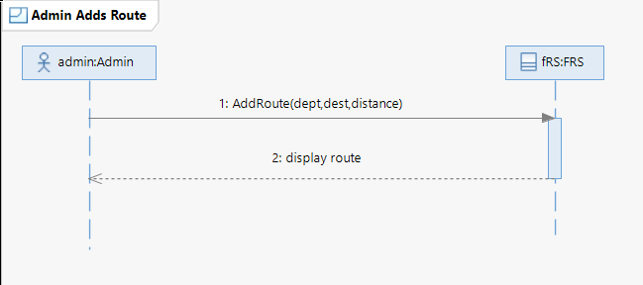

## Sequence Diagram: Add Route

### Add Route

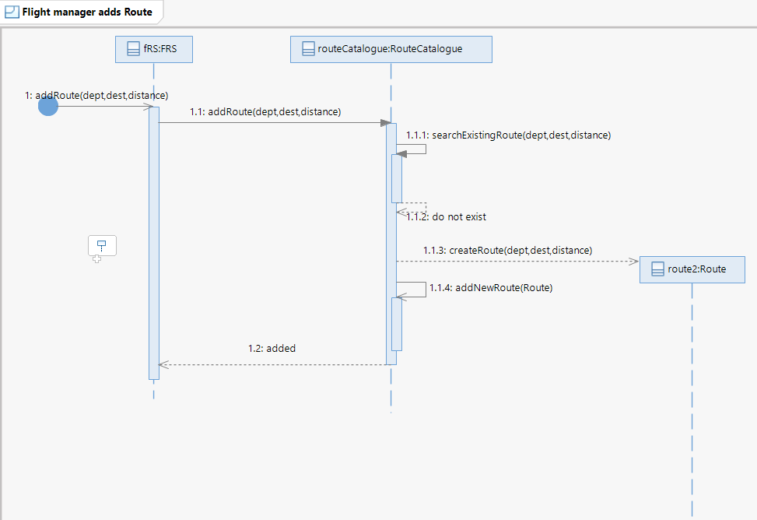

## UC-09: Updating a route

|  |  |
| --- | --- |
| **Section** | **Content / Explanation** |
| **Designation** | UC-09 |
| **Name** | Updating a route |
| **Priority** | Important for system’s success: Medium  Technical Risk: Medium |
| **Scope** | This use case deals with how the Flight Manager updates a route in the FRS . |
| **Criticality** | Medium |
| **Level** | User-goal |
| **Description** | The Flight Manager select the route to change and enter the entries (departure, destinations, stop) he want to change in the route |
| **Trigger Event** | The Flight Manager wishes to update route information. |
| **Primary actor** | Flight Manager |
| **Stakeholders and interests** | Passenger: He wants to check the routes of flight.  Flight Manager: he wants to keep checking every route.  He wants to manage the route. |
| **Pre-Conditions** | The Amin must be logged in.  The Flight Manager must be in the route management portal. |
| **Post-Conditions** | Route is updated.  Route records are updated. |
| **Result** | Route updated. |
| **Main Scenario** | 1. The Flight Manager selects and updates a route option. 2. The FRS will fetch the routes from the database and display routes to the Flight Manager. 3. The Flight Manager selects the route he wants to update. 4. The FRS displays details of route and asks the Flight Manager if he wants to change the departure or not. 5. The Flight Manager selects the change the departure option and enters the new departure. 6. This gives the Flight Manager option if he wants to change the destination or not. 7. The Flight Manager selects to change destination and enters new destination. 8. The systems check if routes contain the stops and ask if the Flight Manager wants to change the stops or not. 9. The Flight Manager changes the stops. 10. FRS display the update route gives Flight Manager the option to   10.1Confirm the route.  10.2 Cancel the route.  10.3Change the route.   1. The Flight Manager confirms the route. 2. The FRS checks the database if the route is already present in the database and updates the route if it is not found in the database. |
| **Alternative Scenario** | 5a. The Flight Manager selects to not change the departure option.       5a.1 Go to step 6.  7a. The Flight Manager selects to not change the destination.       7a.1 Go to step 8.  8a. The route does not contain any stops. cancel the route option.        8a.1 Go to 10  8b. The Flight Manager does not want to change the stop.         8b.1 Go to step 10.  10a. The Flight Manager select cancel the route option.        6a.1 The FRS brings the Flight Manager back to the route management portal.  10b. The Flight Manager selects a change route option.         10b.1 Go to step 4.    12a. The route is already present.         10a.1 The FRS will display message that route is already stored and give Flight Manager the option:  1. Add another route  2. Cancel the route.         10a.2 the Flight Manager select add another route.         10a.3 got to step 4.  10a.2.1 The Flight Manager cancels the route.         10a.2.1.1 The FRS takes Flight Manager to route management portal. |
| **Exception Scenario** | The FRS  server is down.  (1)  Refresh and update the route again. |

## System Sequence Diagram: Updating a route

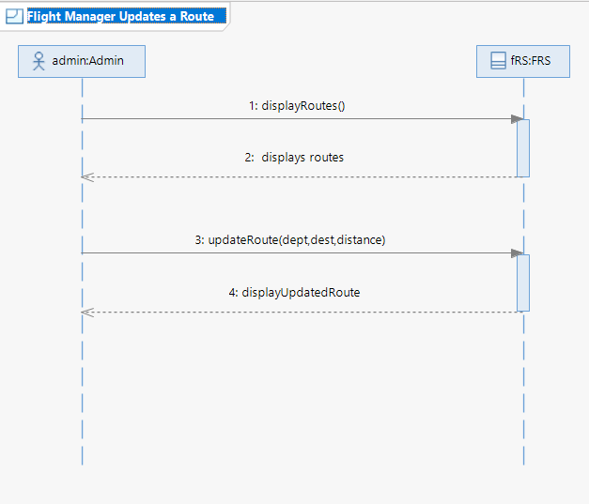

## Sequence Diagram: Updating a route

### 1. Display Routes:

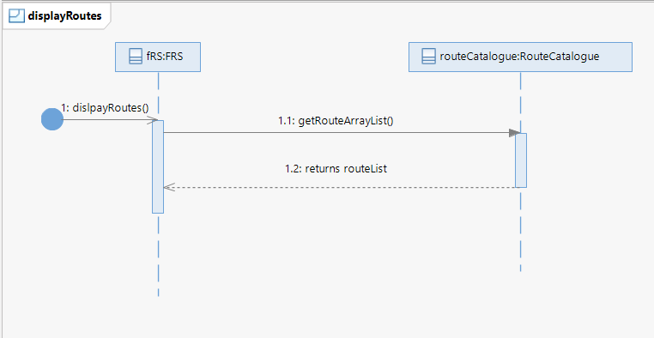

### 2. Update Route():

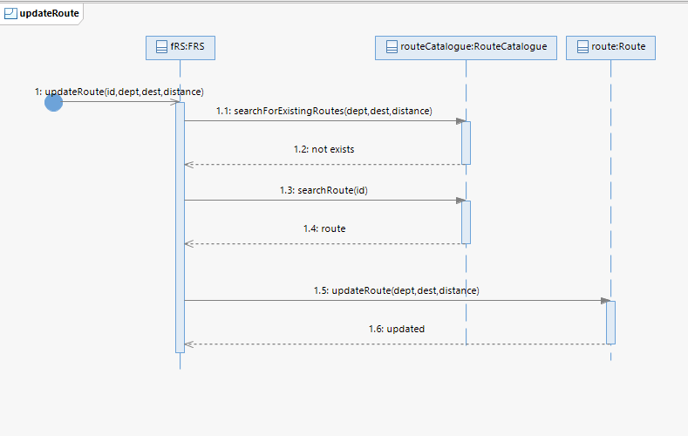

## UC-10: Removing a route

|  |  |
| --- | --- |
| **Section** | **Content / Explanation** |
| **Designation** | UC-10 |
| **Name** | Remove a route |
| **Priority** | Important for system’s success: Medium  Technical Risk: Medium |
| **Scope** | This use case deals with how the Flight Manager removes a route in the FRS . |
| **Criticality** | medium |
| **Level** | User-goal |
| **Description** | The Flight Manager selects the route to remove and the route is removed from the database and information is updated. |
| **Trigger Event** | The Flight Manager wishes to remove the route. |
| **Primary actor** | Flight Manager |
| **Stakeholders and interests** | Passenger: He wants to check the routes of flight.  Flight Manager: he wants to keep checking every route.  He wants to manage the route. |
| **Pre-Conditions** | The Flight Manager must be logged in.  The Flight Manager must be in the route management portal. |
| **Post-Conditions** | Route is removed.  Route records are updated. |
| **Result** | Route removed. |
| **Main Scenario** | 1. The Flight Manager selects a route option. 2. The FRS will fetch the routes from the database and display routes to the Flight Manager. 3. The Flight Manager selects the route he wants to remove. 4. The FRS displays details of the route and asks the Flight Manager for the confirmation. 5. The Flight Manager confirms the deletion. 6. The FRS deletes the route from the database. |
| **Alternative Scenario** | 2a. The FRS database is empty.    2a.1 The FRS gives the Flight Manager the message that the database is empty and navigates the Passenger to the route management portal.    5a. The Flight Manager select cancel the route option.        5a.1 The FRS brings the Flight Manager back to the route management portal. |
| **Exception Scenario** | The FRS  server is down.  (1)  Refresh and remove the route again. |

## System Sequence Diagram: Route Removing

### Removing a route

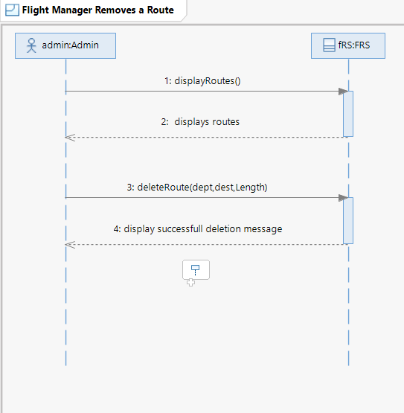

## Sequence Diagram: delete Route

### Delete Route

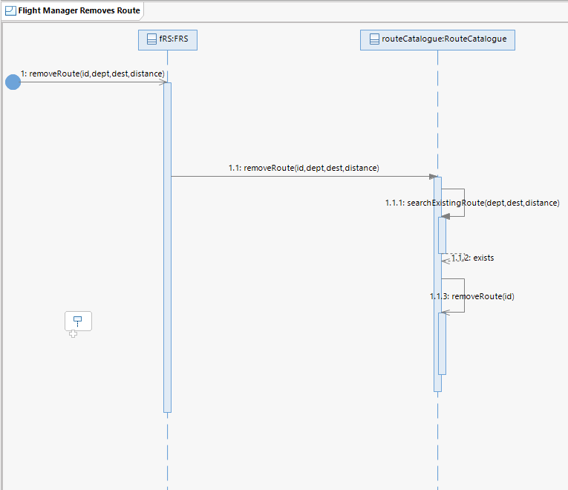

# Payment

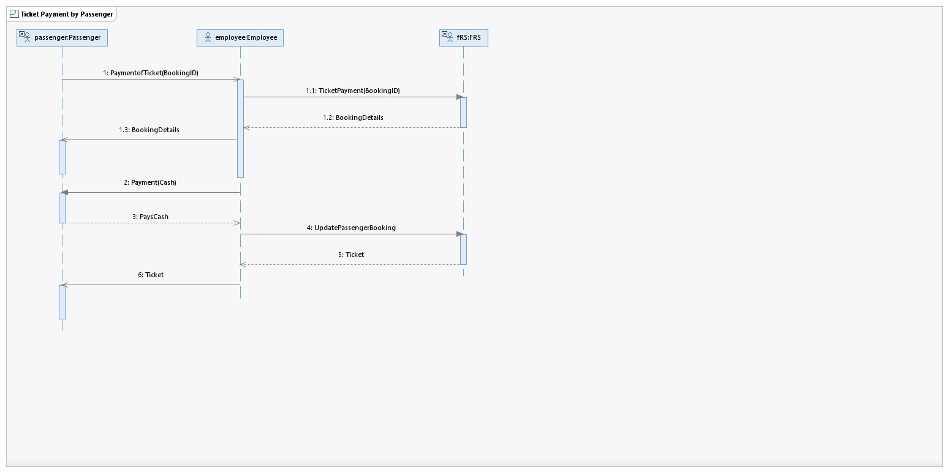

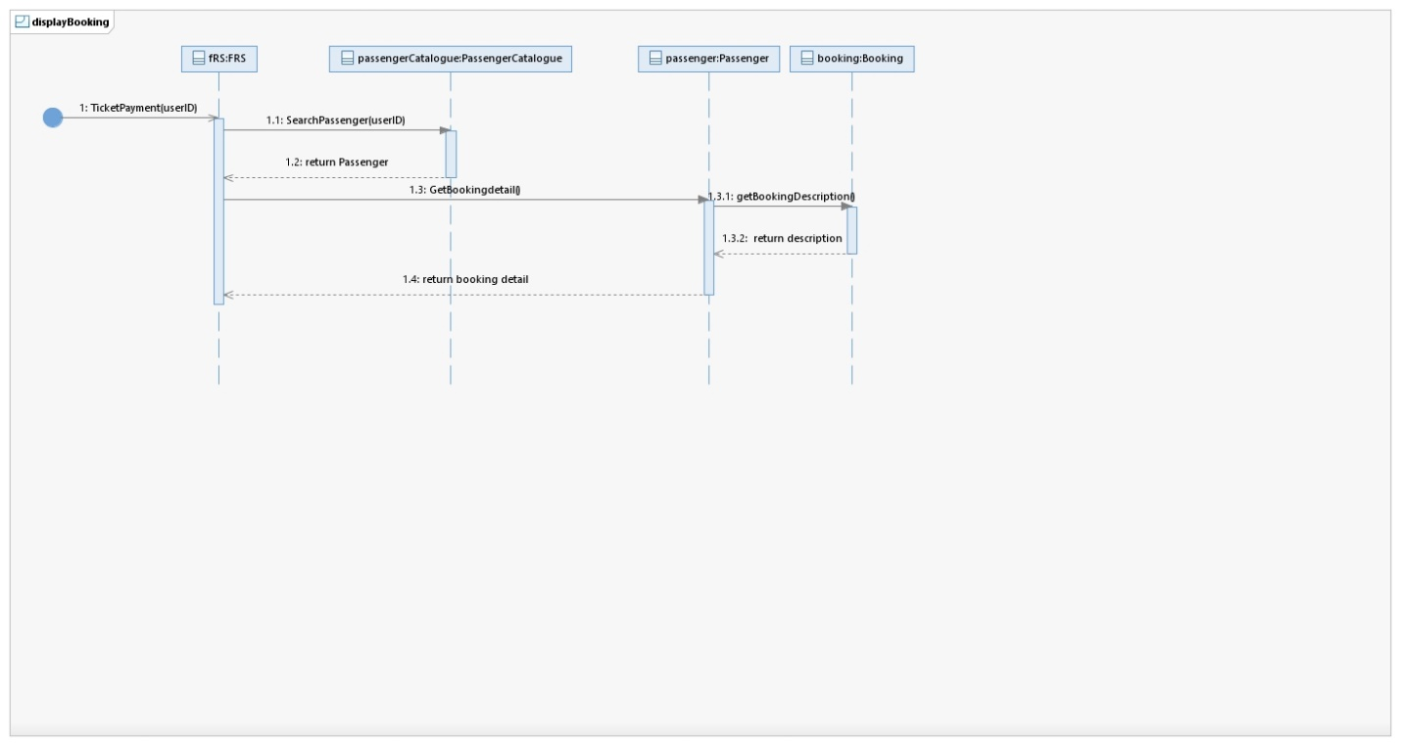

## Sequence Diagrams: Payment

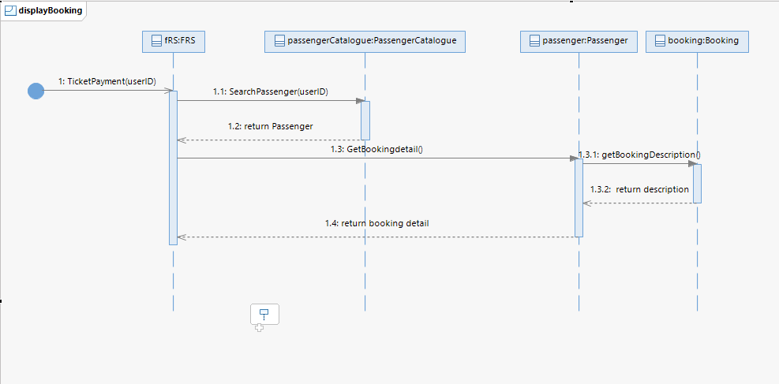



## UC-11.1: Payment with cash

|  |  |
| --- | --- |
| **Section** | **Content / Explanation** |
| **Designation** | UC-11 |
| **Name** | Payment with cash |
| **Priority** | Important for system’s success: High  Technical Risk: High |
| **Scope** | This use case deals with how the Passenger processes payment. |
| **Criticality** | High |
| **Level** | User-goal |
| **Description** | The Passenger selects to pay through cash and the FRS tells the Passenger to pay 3 hours before the flight departure and if the Passenger pays before the time, then the seat is reserved else it is set free to be booked. |
| **Trigger Event** | The Passenger wishes to pay through cash. |
| **Primary actor** | Admin |
| **Stakeholders and interests** | Passenger: He wants to pay for the booked flight.  Admin: he wants to keep a check of every Passenger who has reserved and paid for the flight.  He wants to manage flight reservations. |
| **Pre-Conditions** | The Passenger must have booked a flight.  The Passenger must be in the Airline Office  The Employee dealing the Passenger must be logged in to the FRS |
| **Post-Conditions** | Payment is done.  Flight Records are updated.  Seating records are updated. |
| **Result** | Payment received. |
| **Main Scenario** | 1. The Passenger goes to the Airline Office. 2. The passenger tells the Employee for Ticket Payment 3. The Employee Selects Ticket Payment from the FRS. 4. The Employee asks for Booking ID of the Passenger. 5. The Employee enters the Booking ID into the FRS. 6. FRS displays the calculated fare, Passenger CNIC and flight time. 7. The Employee collects the Payment from the passenger. 8. The Employee updates the payment of the Passenger. |
| **Alternative Scenario** | Main Scenario of UC-11, UC-12. |
| **Exception Scenario** | The FRS server is down.  The Employee can’t log in. |